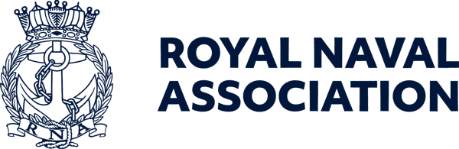

Semaphore Short Friday 19 June 2026

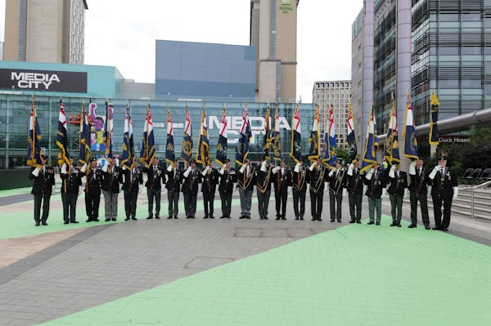

BZ Salford!

The RNA National Conference and AGM in Salford promised to be a memorable weekend – and so it proved.

From the lively Meet & Greet on Friday evening, featuring Elvis, through the AGM and Gala Dinner on Saturday to the Drumhead Ceremony on Sunday morning, the organising team from the City of Salford Branch managed to deliver an excellent programme and won universal acclaim – a fitting tribute to their late colleague S/M Steve Caulfield, to whose memory the weekend was dedicated.
There was plenty of business covered at the AGM – for a full report see the July edition of the Semaphore Circular, published on Friday 3 July – but amongst the main issues dealt with were:
- Association officers will take a close look at the organisation's admin processes to see where the workload on Branch officials can be eased;
- It was agreed that the 2028 National Conference will be hosted by Plymouth Branch.
For the first time the AGM was streamed live online via Zoom, with more than 20 users logging in to follow proceedings (see below).
Conference Raffle winners were:
1st Prize £500 – M Hague - Skipton
2nd Prize £300 – E Mitchell - Harwich
3rd Prize £200 – T Potter – Londonderry
So now there is work to be done as a result of decisions at the AGM, and minds will turn to the 2027 Conference weekend, to be held in the historic city of Durham on 4-6 June, and for which Area 11 National Council Member S/M Ros Hastie-Murray gave a hint of what delegates and observers can expect.

  Kate takes up the reins
  Conference weekend was a last hurrah for two prominent figures at Central Office. General Secretary/CEO Bill Oliphant has left to take up an appointment in the Middle East, while Membership Secretary Sara Field has made the rather shorter transfer to Whale Island, where she has a new role at Royal Navy & Royal Marines Charity (RNRMC). We wish them both all the best in their new careers.
  While the recruitment process for Bill's successor is under way we have a new Interim General Secretary/CEO – our Governance expert Kate Aldous (right) has stepped up to keep things ticking over.
  You can see Kate's biography at https://www.royal-naval-association.co.uk/royal-naval-association-appoints-kate-aldous-as-interim-chief-executive-officer, or see the July edition of the Semaphore Circular.
  Sara's relief is already in place – former WO Caterer Jon Boreham is now in the hot seat that Sara so successfully occupied.
  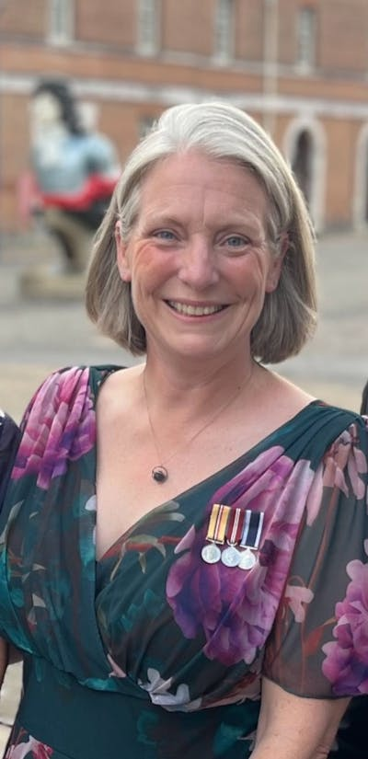

Conference – how was it for you?
The weekend might be over, but there is still much to be gained from the successful gathering at Salford.
One way that delegates can help is by sending their feedback to Central Office to ensure we can fine-tune any elements of the AGM or wider weekend for future events.
Just as importantly, we would like to hear back from shipmates who made use of the experimental livestream that we set up. Did it work for you? What did you like – and what could be done better (and yes, the varying microphone techniques were noted!).
Let us know on ams@rnassoc.org
The benefit of the Zoom link was perhaps best demonstrated when delegates' attention was drawn to the fact that our Malta Branch was online and participating in the AGM, which brought a hearty round of applause.

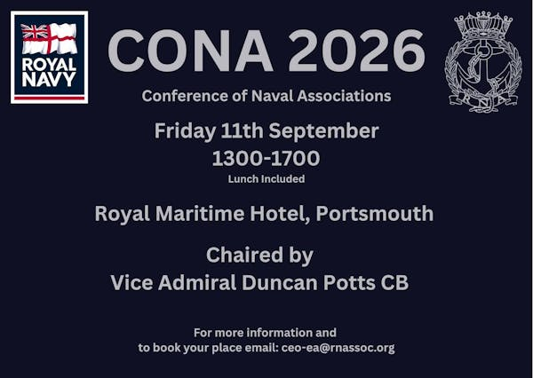

Naval associations to gather in Portsmouth
What does the future of the Naval family look like?
The 2026 gathering of CONA (Conference of Naval Associations) members brings together representatives from Naval associations across the UK to share ideas, strengthen connections and discuss matters that affect the wider Naval community.
Whether you're involved with an association, a Branch committee, or simply interested in the organisations that support those with a Naval story, CONA offers an opportunity to meet fellow members, hear from guest speakers and contribute to important discussions.
The gathering will be on the afternoon of Friday 11 September at the Royal Maritime Hotel in Queen Street, Portsmouth, between 1300 and 1700 – lunch included..
To book your place, email ceo-ea@rnassoc.org Delegates also get a 10 per cent discount when booking a room at the Royal Maritime Hotel if they quote CONA.

  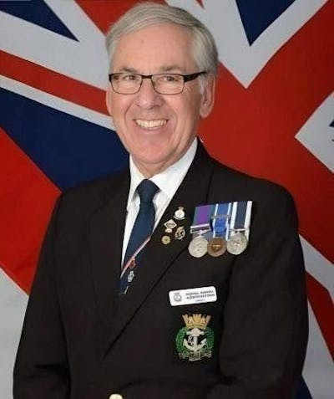
  Plaudits for award winners
  Congratulations to shipmates who were recognised in the King's Birthday Honours this month.
  Terry Whitty (left) was awarded the British Empire Medal (BEM) in recognition of his outstanding dedication to supporting members of the Naval community as Lead Mentor in the RNA’s HMS Raleigh Mentoring programme.
  Also recognised were Vice Admiral Sir Andrew Kyte RN (KBE) and Lt Adam Lappin RNR (MBE).

Awards deadlines

Please note that nominations for the Northern Irish Veterans Awards close on 30 June, with the final ceremony taking place on 22 October.
Go to https://theveteransawards.com to see the categories and access the nomination form.
The application process for the English Veterans Awards opened on 1 June, closes on 17 August, and a final awards ceremony will be held at the De Vere Cotswold Water Park on 1 October – for more details follow this link: https://veteransawards.co.uk/english-veterans-awards/

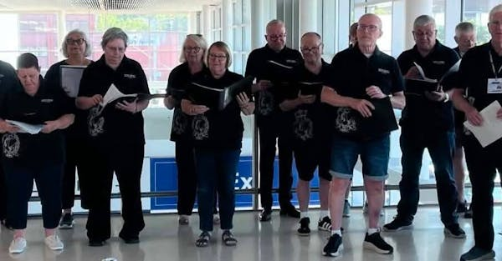

Music to our ears

Members of the RNA Choir took part of the celebrations marking the 50th anniversary of Portsmouth International Port, joining the programme for a vibrant open day (pictured above).
The event welcomed thousands of visitors from the local community, offering the opportunity to discover more about the port’s day-to-day operations while celebrating five decades of achievement and service.
Throughout the day the RNA Choir entertained visitors with a selection of songs, helping to create a warm and welcoming atmosphere for people of all ages.

Armed Forces Day

Don't forget Armed Forces Day is next weekend (Saturday 27 June) with the national event being hosted by Rushmoor Borough Council, based at Queen's Avenue, Aldershot, with a nod to the military significance of nearby Farnborough.
Although that is the focus of the day, hundreds of other events will be held across the country in the days before (and sometimes after) that date – for more details of associated events in your area see https://www.armedforcesday.org.uk

 |  |  |  |  |  |  |  |  |  |  | 

